Corrections for Chainages
Listed below are several corrections that can be applied to chained distances to minimize systematic errors and to correct for the effects of the physical environment of the measurement process.
- Temperature
- Standardisation
- Catenary (Sag)
- Slope
- Tension
The expressions below are used on the following pages:
L - true length  l - length as measured  t_{o} - temperature of standardization  t - temperature at observation  t - (t - t_{o})  M - mass per unit length  t_{o} - standard tension | T (T - T_{o})  T - Field tension  c - coefficent of linear expansion  E - Young modulus  q - angle of slope in degrees  l' - actual standardized length  L - correction to lenght

1. Temperature  Most materials expand and contract with temperature change, and this effects taped distances. If a tape has stretched due to heat it will read shorter than it would at its normal (or standard) temperature.  The corrected length is computed as follows:  L = 1 + 1.c.t  For example, if;  t = 20°C (usual)  t = 37°C (hot!)  l = 79.984  c = 1.15 x 10⁻⁵m/°C  then:  L = 79.984 + 79.984 x 1.15 x 10⁻⁵ x 17  = 80.000m  So, if a distance of 79.984m was measured at this temperature, the actual distance would have been 80.000m. Conversely, if it was needed to lay out a line of 80.000m then a tape distance of 79.984 would be used | 2. Standardisation  The chain or tape being used may not be the correct length so it may always over or under read (a systematic error). This can be corrected by:  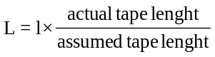  For example: l = 226.20  assumed tape length = 30.00m  actual tape length = 30.005 m  then: 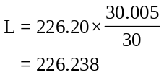  A tape is standardized by comparison with a "standard" tape or by measuring a definite "known" distance
3. Catenary (Sag)  If the tape cannot be supported for its length then it will hang freely under the influence of gravity. The shape the tape will take is known as a catenary and can be determined mathematically.  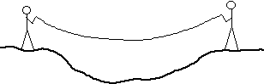 | 4. Slope  All plan distances are always quoted as horizontal distances, therefore any distancenot measured on the horizontal will need to be corrected for slope. Slope correction must always be considered, and either eliminated in the field or mathematically compensated.  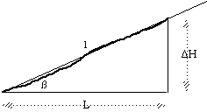  - Reduction by slope angle  The horizontal distance is given by L = l x cos  - Reduction by differences in height  L = (l² - h²)^{1/2}

5. Tension
A tape is a given length when pulled with a certain tension. If the tension changes then so does the tape length. The correction is as follows:
L= | l x T
L= | E x A
where T is the change in tension and A is the cross-sectional area.
However, it is far simpler to pull the tape at the correct tension and eliminate this altogether.

